

**Course Title: Pervasive Computing and App Development Lab**

**Course Code: CSE335**

**Submitted To:**

**Name:** Md Hasanuzzaman Dipu

Assistant Professor

Department of Computer Science and Engineering

Daffodil International University

**Submitted By:**

**Name:** Md Sujon Mia

**ID:** 212-15-14701

**Section: 59-D**

Department of Computer Science and Engineer

**Project Introduction**

The rapid growth of mobile technology has led to an increasing demand for versatile and efficient mobile applications. Flutter, an open-source UI software development toolkit by Google, provides a powerful framework for building high-performance, cross-platform apps from a single codebase.

This project leverages Flutter to develop four distinct applications: a weather app, a quiz app, a scientific calculator app, and a personal portfolio app. Each app is designed to address specific user needs and demonstrate the diverse capabilities of Flutter in creating responsive and user-friendly interfaces.

The weather app offers real-time weather updates, the quiz app provides an engaging platform for learning, the scientific calculator app ensures precise and complex calculations, and the personal portfolio app effectively presents professional accomplishments.

Through this project, we aim to showcase the potential of Flutter in developing a wide range of mobile applications, highlighting its efficiency, flexibility, and performance.

**Login/SignUp/Forgot**

**1. Long Page:** This is Login Home Page. here 3 Button

- Login.

- Register Now.

- Forgot Password.

Here Use **Firebase Login Authentication**

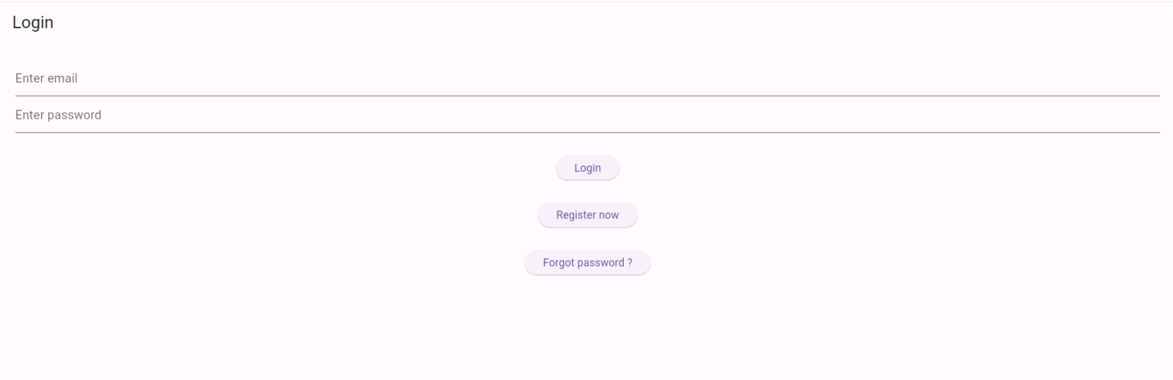

**2. Firebase Login Information**

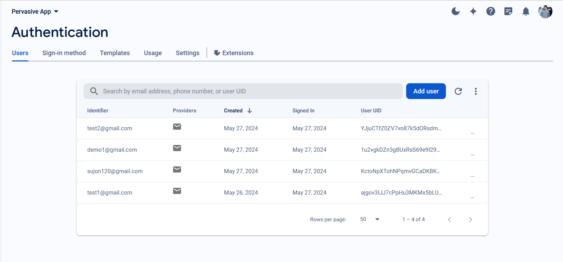

**3. Register Now:** When user click Register Now button ,then go Signup page and user need create account use Gmail and Password.

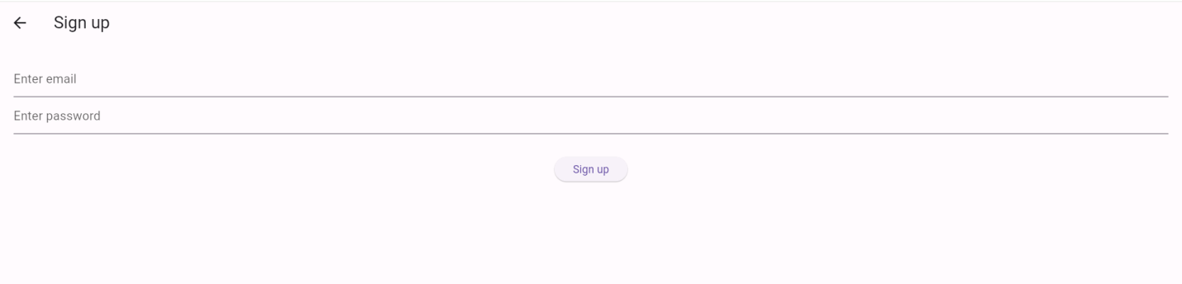

* Inter **Gmail and Password** then press **Sign Up button** and goes to **Merge App** Home Page. Like this.

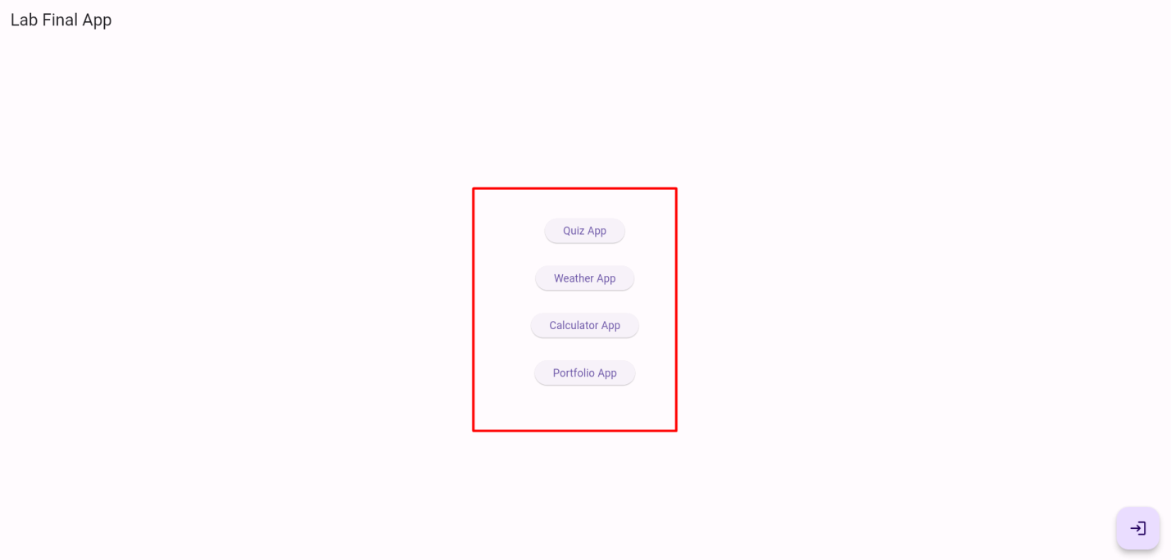

* And Here we use **Sign Out Button** .when press **Sign Out button** then go to **Login** home Page:

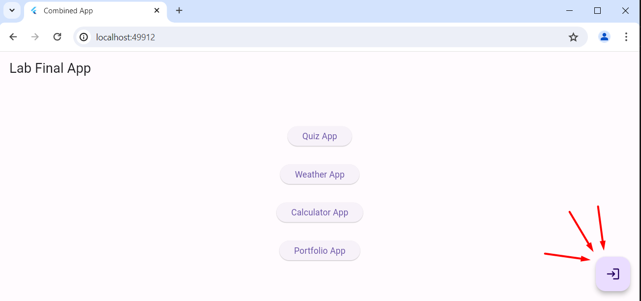

4. **Forgot Password :** press forgot password and then put valid One Gmail and then Send Link button. then you get link reset password via provided Gmail.

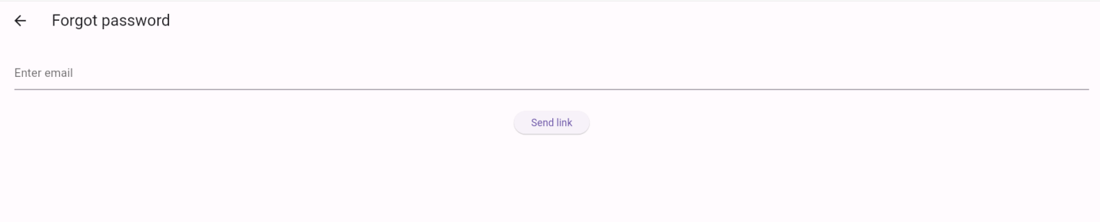

**Quiz App**

This is Quiz App home page. Here user make 2 decision

1. Start Quiz
2. Add question

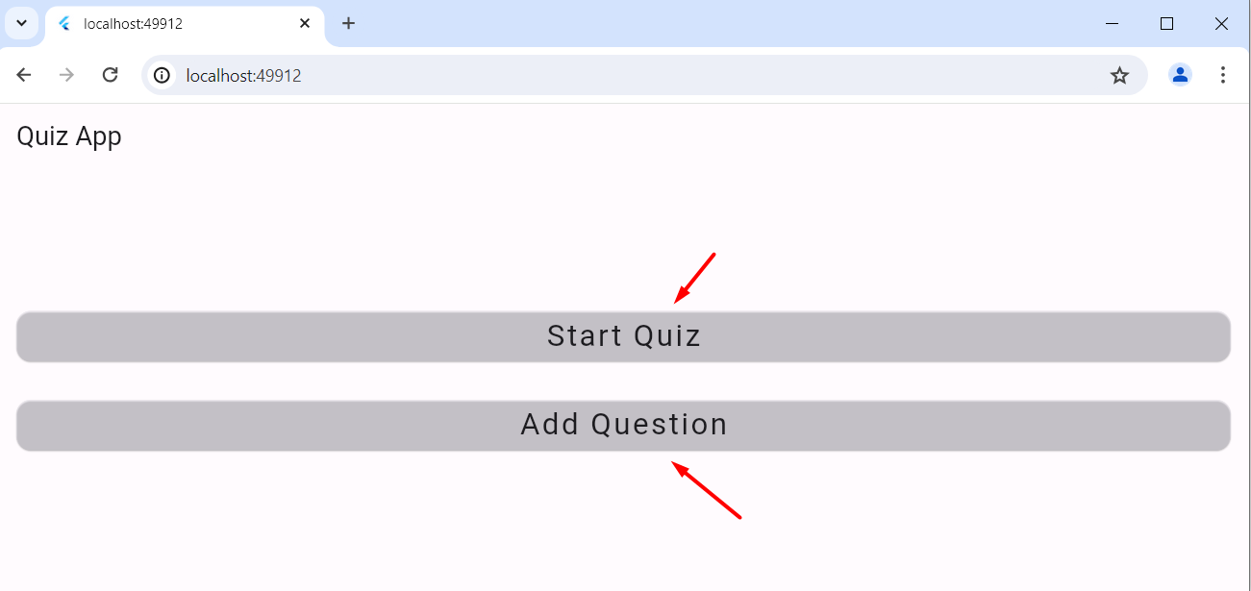

**Start Quiz:** when user click start quiz here show question. And each question has individual time. If time end then automatically move next question. User need to select one answer and press Next button.

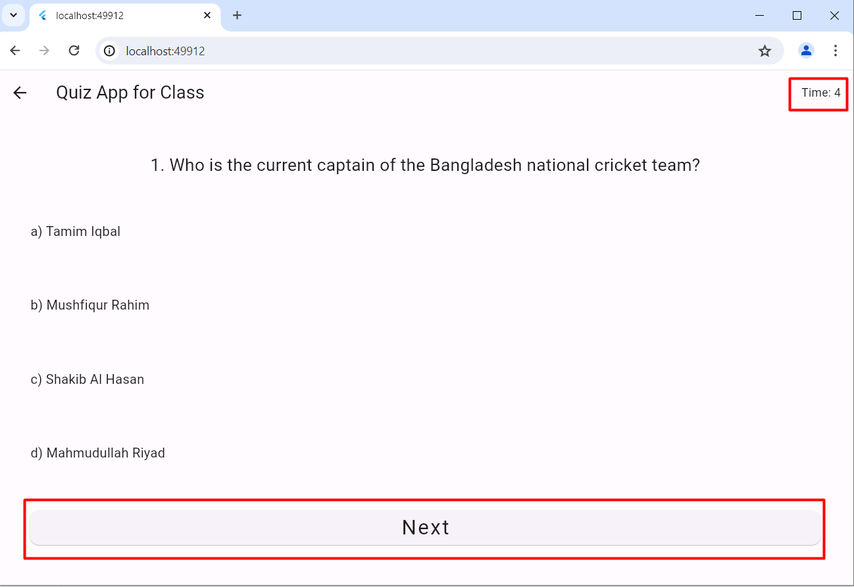

**Finish Page :** This page shows

1. Total time of quiz.
2. Total marks and Percentage
3. User Start quiz again
4. And share their score result

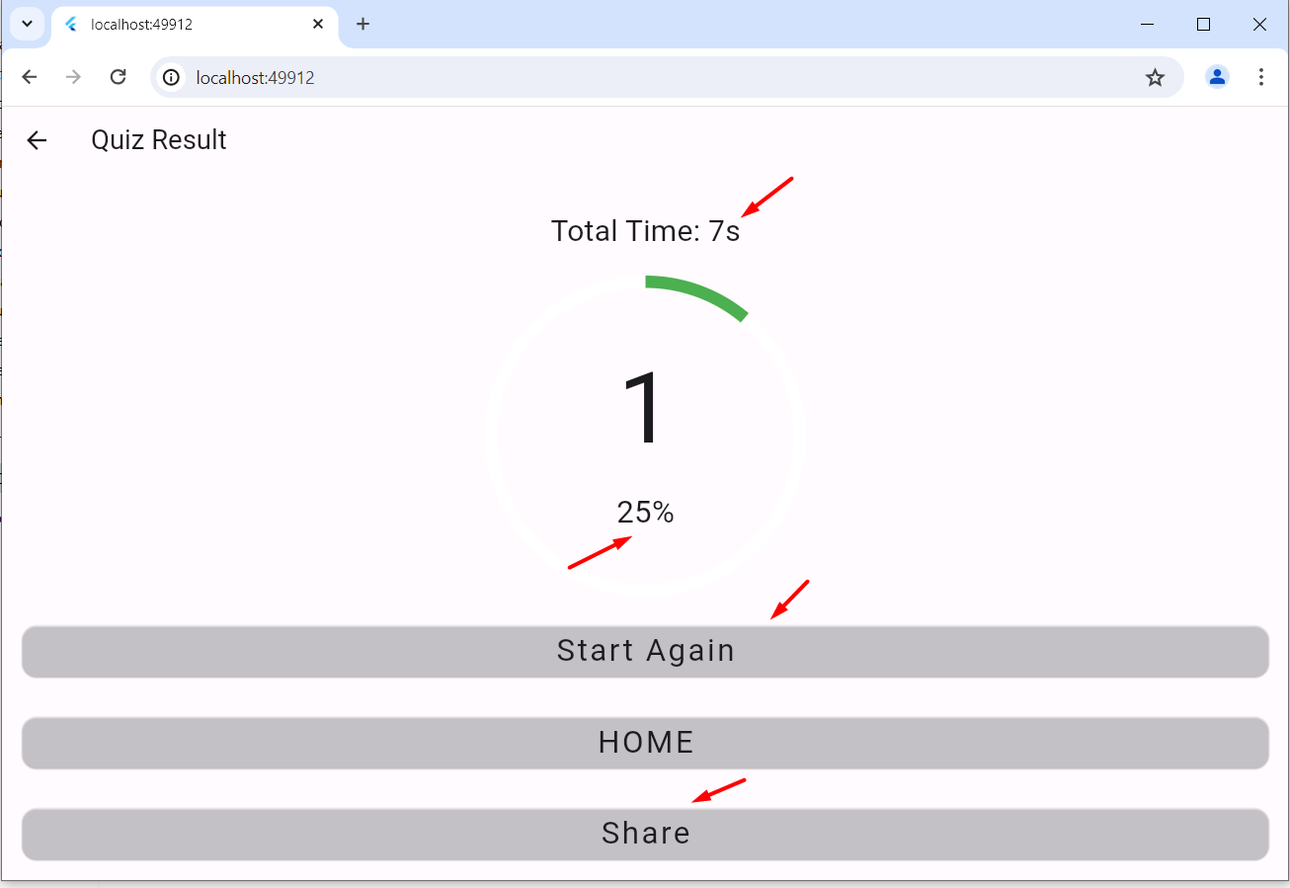

**Add Question :** Here user can add own question. First add question title and then add choice option. Then Select correct answer. And then Press Add Question. And this question will feature .

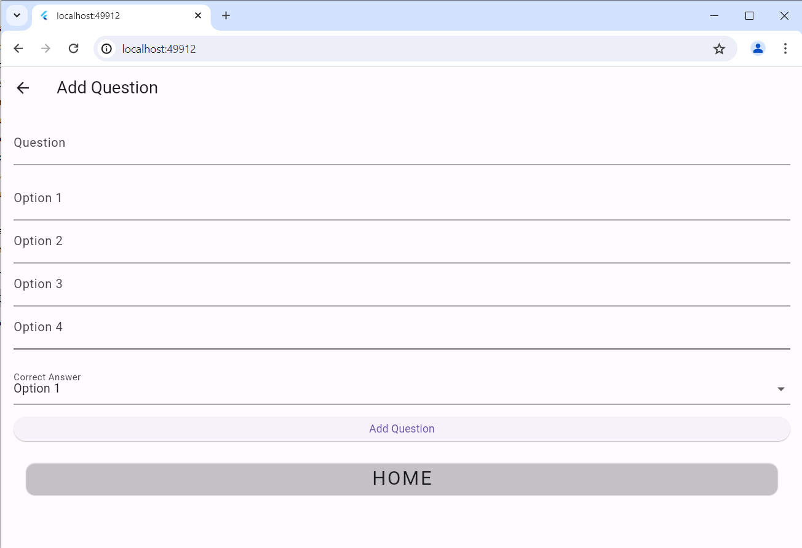

**Weather App**

**Introduction :** The purpose of this lab is to create a weather app using Flutter, a popular UI toolkit for building natively compiled applications for mobile, web, and desktop from a single codebase. The app will fetch and display weather data for a given location using an external weather API.

### **Requirements :**

* A valid API key from OpenWeatherMap.
* Flutter and Dart installed on your development machine.
* A working knowledge of Dart programming language.

**Design and Architecture:**

* Model: Represents the weather data.
* View: UI components displaying the weather data.
* ViewModel: Handles business logic and interaction between Model and View.

**UI Design :**

* Home Screen: Allows users to enter a city name and fetch the weather data.
* Weather Screen: Displays the current weather, including temperature, humidity, wind speed, and weather description.

**Design Output**

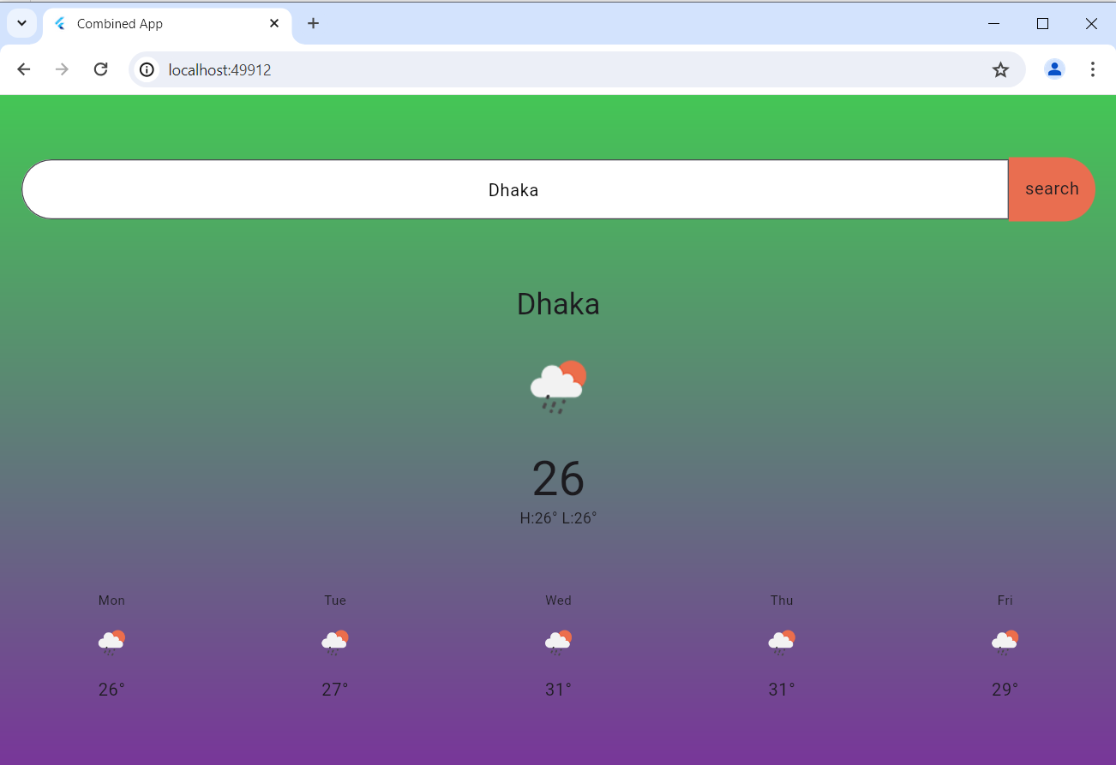

**Calculator App**

### **Introduction :** The purpose of this project is to create a scientific calculator app using Flutter, a UI toolkit for building natively compiled applications for mobile, web, and desktop from a single codebase. The app will perform basic arithmetic operations as well as advanced scientific functions such as trigonometric, logarithmic, and exponential calculations.

### **Objectives**

* To understand advanced Flutter and Dart programming concepts.
* To learn how to build a complex user interface with Flutter.
* To implement state management for a more complex app.
* To handle user inputs and perform a variety of mathematical operations.

### **Tools and Technologies**

* **Flutter SDK**: Version 3.0.0
* **Dart SDK**: Version 2.17.0
* **IDE**: Visual Studio Code
* **Packages**: math_expressions for mathematical computations

### **Requirements**

* Flutter and Dart installed development machine.
* Advanced knowledge of Dart programming language.
* Familiarity with Flutter widgets and state management.
* Knowledge of mathematical functions and operations.

### **Design and Architecture**

#### Application Structure

* **main.dart**: Entry point of the application.
* **calculator.dart**: Contains the Calculator widget and business logic.

#### **UI Design**

* **Calculator Screen**: Consists of a display area for the input and result, and a grid of buttons for digits, basic operations, and scientific functions.

**Calculation :**

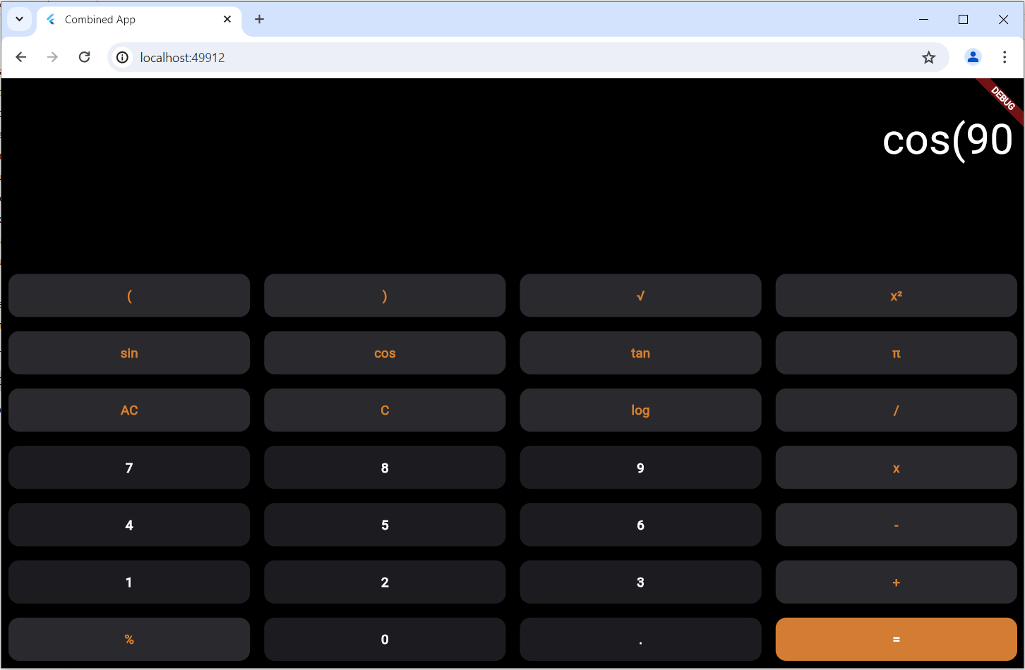

**Result Cos(90):**

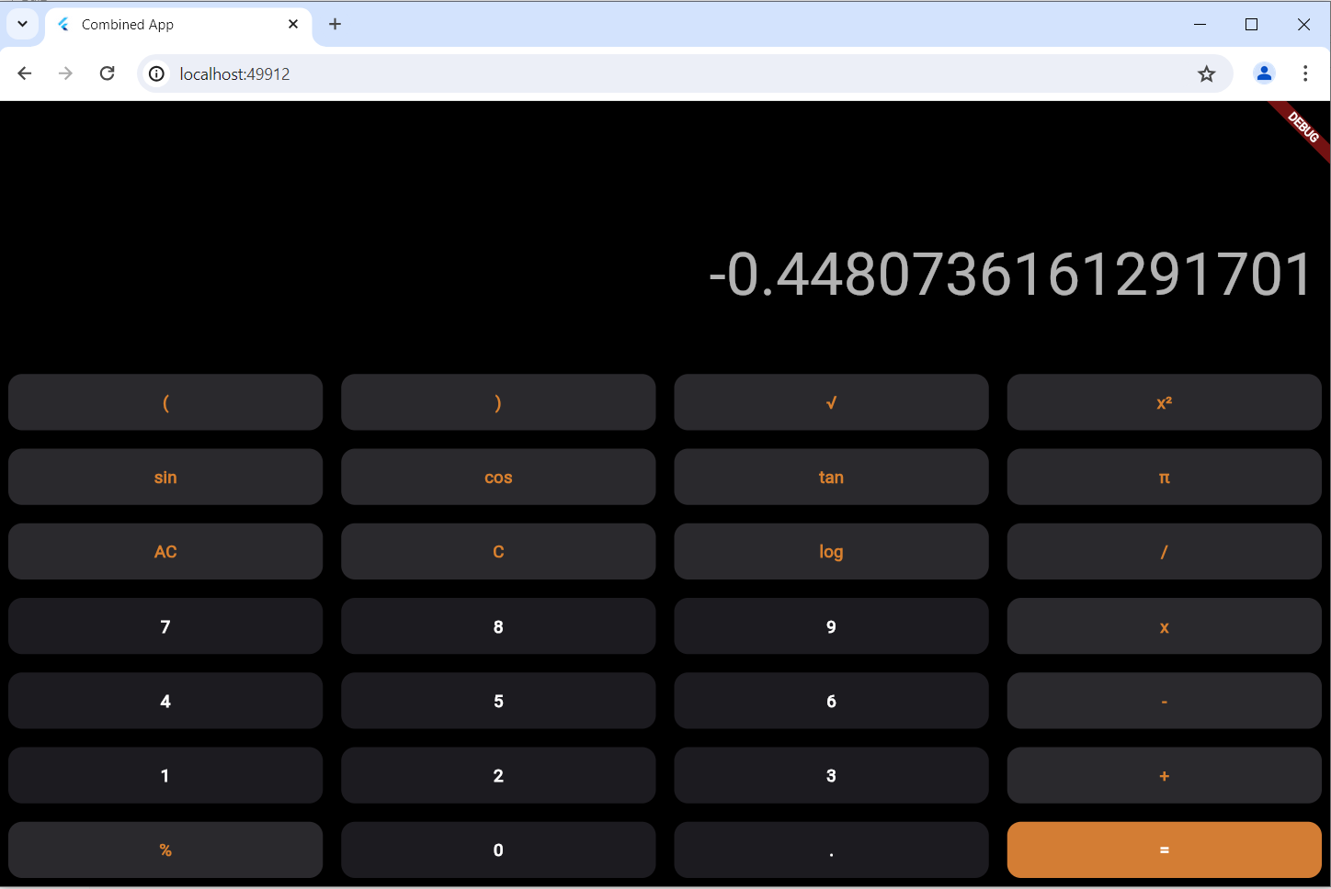

**Portfolio App**

### **1. Introduction**

The purpose of this project is to create a personal portfolio website using Flutter, which will showcase about, personal projects, skills, and experience. This website will serve as an online resume to attract potential employers or clients.

### **2. Objectives**

* To create a responsive and visually appealing portfolio website using Flutter.
* To learn how to manage routing and navigation in a Flutter web application.
* To integrate various widgets and packages to enhance the functionality and user experience.
* To deploy the Flutter web application to a hosting service.

### **3. Tools and Technologies**

* **Flutter SDK**: Version 3.0.0
* **Dart SDK**: Version 2.17.0
* **IDE**: Visual Studio Code
* **Packages**: url_launcher for external links, flutter_web_plugins for web plugins
* **Hosting**: GitHub Pages, Firebase Hosting

### **4. Requirements**

* Flutter and Dart installed development machine.
* Basic knowledge of Dart programming language and Flutter widgets.
* Familiarity with web development concepts.
* Content for your portfolio, including project descriptions, skills, and personal information.

### **5. Design and Architecture**

#### 5.1. UI Design

* **Home Page**: Introduction with a brief bio and navigation menu.

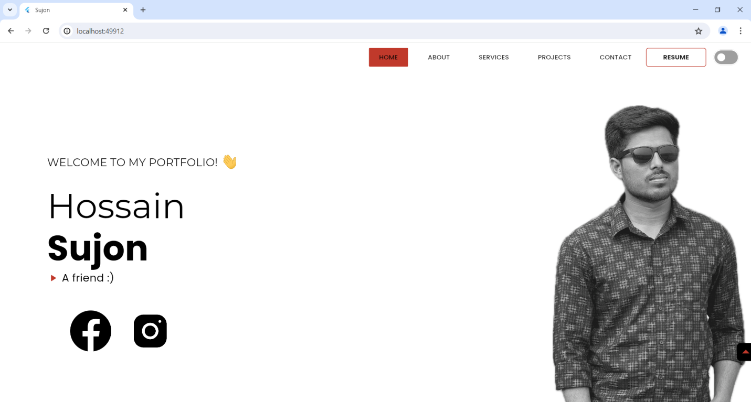

* **About Page**: Detailed information about education, skills, and experience.

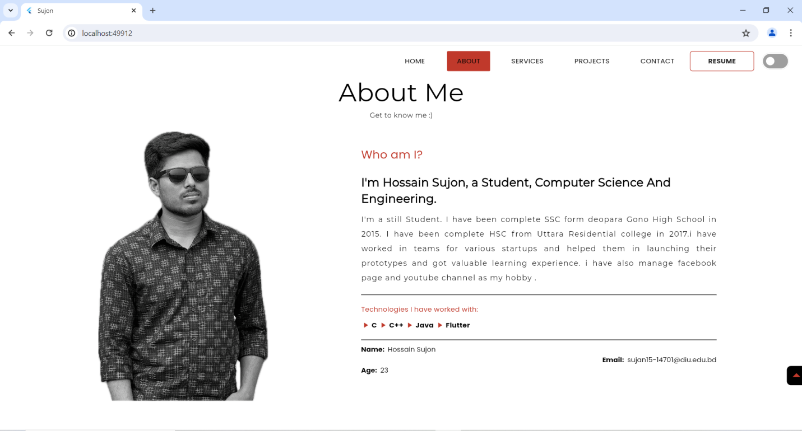

* **Services Page**: The Services page of a personal portfolio website showcases the various services offered by the individual..

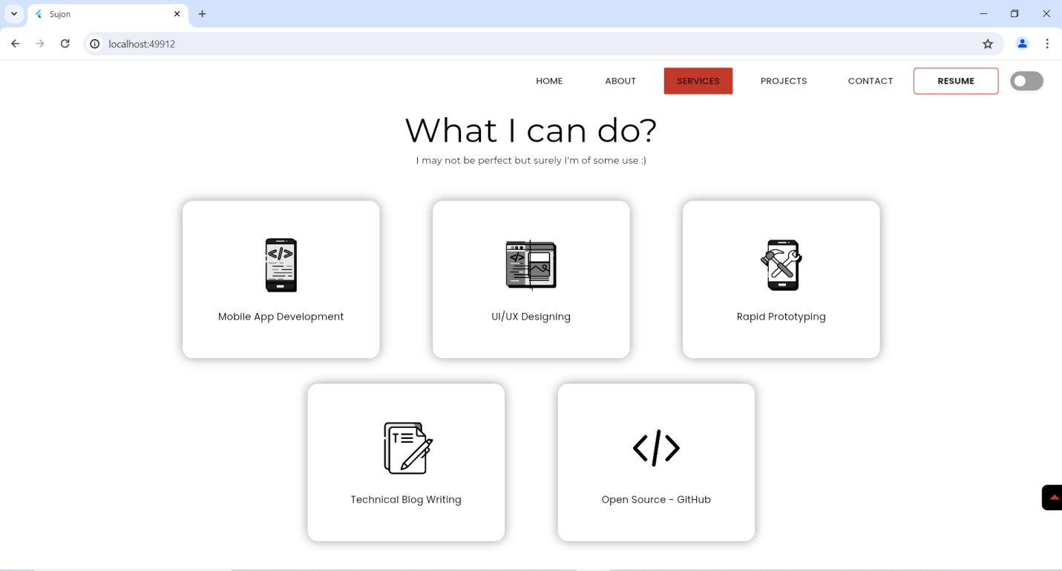

* **Projects Page**: Gallery of projects with descriptions and links.

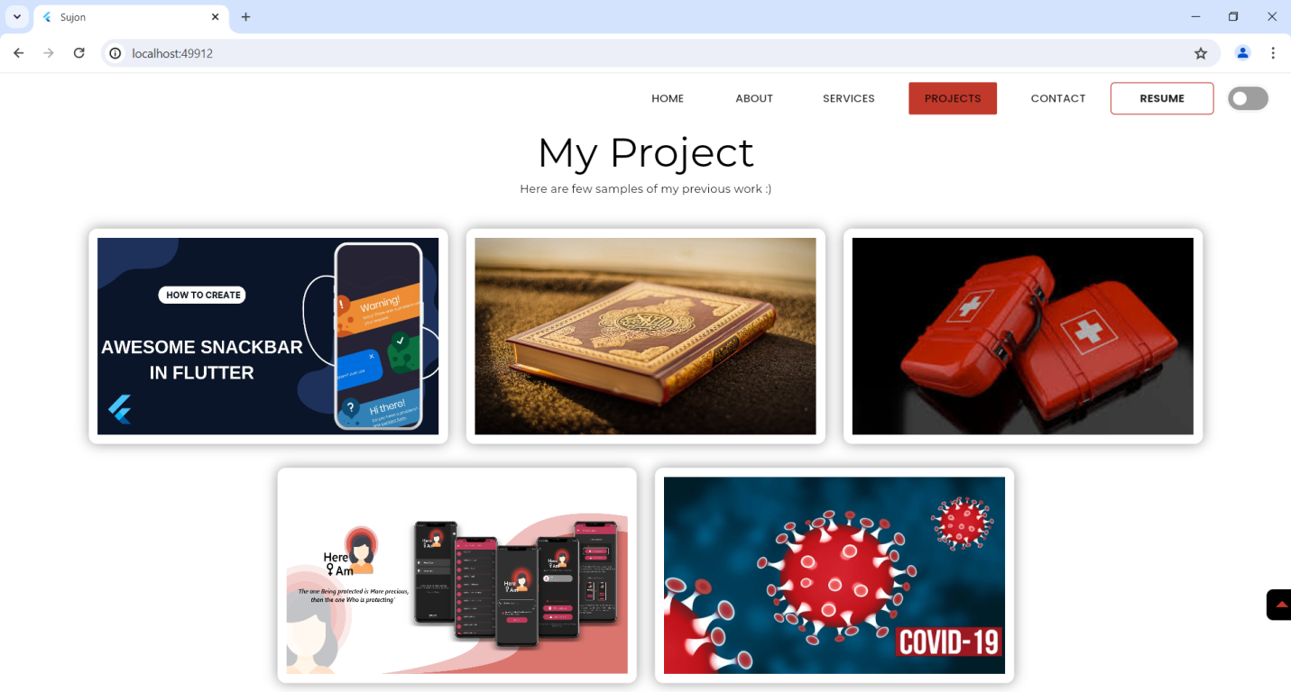

* **Contact Page**: This page show Location, phone number and Email. social media links.

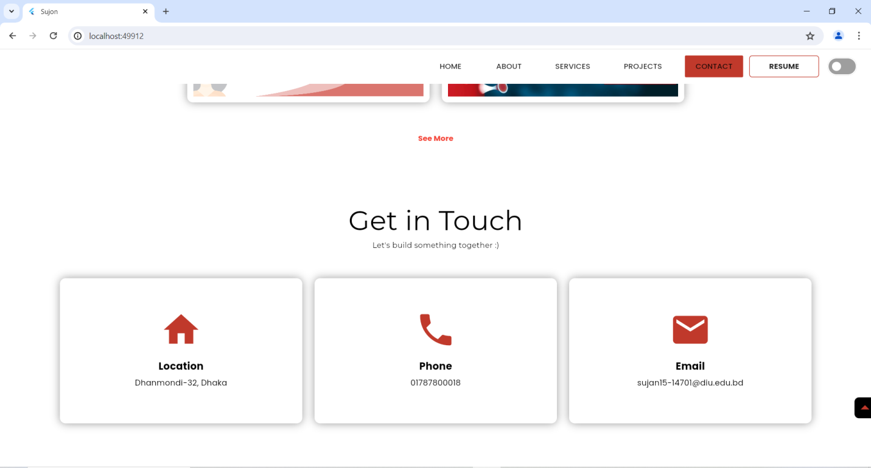

**Resume Section**: this section I add my cv :

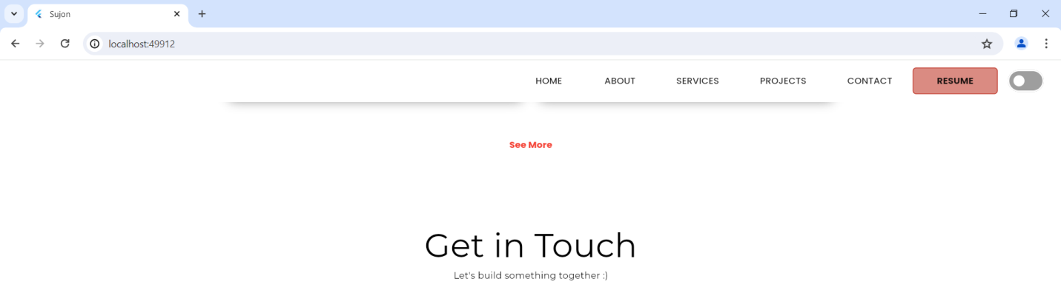

**Conclusion**

This Flutter project successfully developed a weather app, quiz app, scientific calculator app, and personal portfolio app. Each application demonstrates the versatility and power of Flutter for creating robust and user-friendly mobile applications. The weather app provides real-time weather updates, the quiz app offers an interactive learning experience, the scientific calculator app delivers precise calculations, and the personal portfolio app showcases professional achievements effectively. Overall, this project highlights the effectiveness of Flutter in developing diverse applications and sets a strong foundation for further advancements in mobile app development.